**Name : Sarthak Modak Final Year ECE AIML**

**PRN : 1032212305 Batch : FSD G1**

**FSD Laboratory 01**

Aim: Version control with Git.

Objectives:

1. To introduce the concepts and software behind version control, using the example of Git.
2. To understand the use of 'version control' in the context of a coding project.
3. To learn Git version control with Clone, commit to, and push, pull from a git repository.

Theory:

1. What is Git? What is Version Control?

**Git** is a distributed version control system that helps developers track changes in their code, collaborate efficiently, and manage different versions of a project.

**Version Control** is a system that records changes to files over time, allowing users to revert to previous versions, track modifications, and collaborate without overwriting each other's work.

2. How to use Git for version controlling?

**Initialize Git in a project:**

git init

**Check the status of the repository:**

git status

**Add files to staging area:**

git add filename # Add a specific file

git add . # Add all files

**Commit changes with a message:**

git commit -m "Initial commit"

**Connect to a remote repository (e.g., GitHub):**

git remote add origin <repository_url>

**Push changes to the remote repository:**

git push -u origin main

**Pull the latest changes from the remote repository:**

git pull origin main

FAQ:

1. What is branching in Git?

**Branching** in Git allows multiple developers to work on different features or bug fixes simultaneously without affecting the main codebase.

The **main branch (default is main or master)** represents the stable code, while new features or fixes are developed in separate branches.

2. How to create and merge branches in Git? Write the commands used.

**Create a new branch:**

git branch new-feature

**Switch to the new branch:**

git checkout new-feature

**Make changes and commit them:**

git add .

git commit -m "Implemented new feature"

**Switch back to the main branch:**

git checkout main

**Merge the new branch into the main branch:**

git merge new-feature

**Delete the branch after merging (optional):**

git branch -d new-feature

Output: 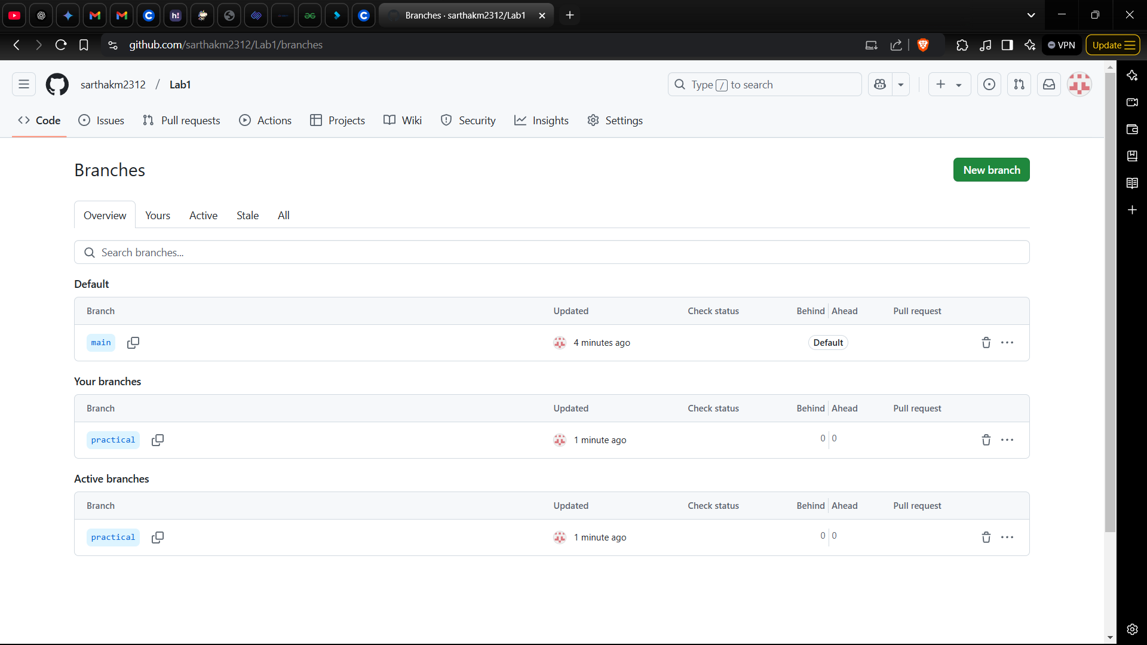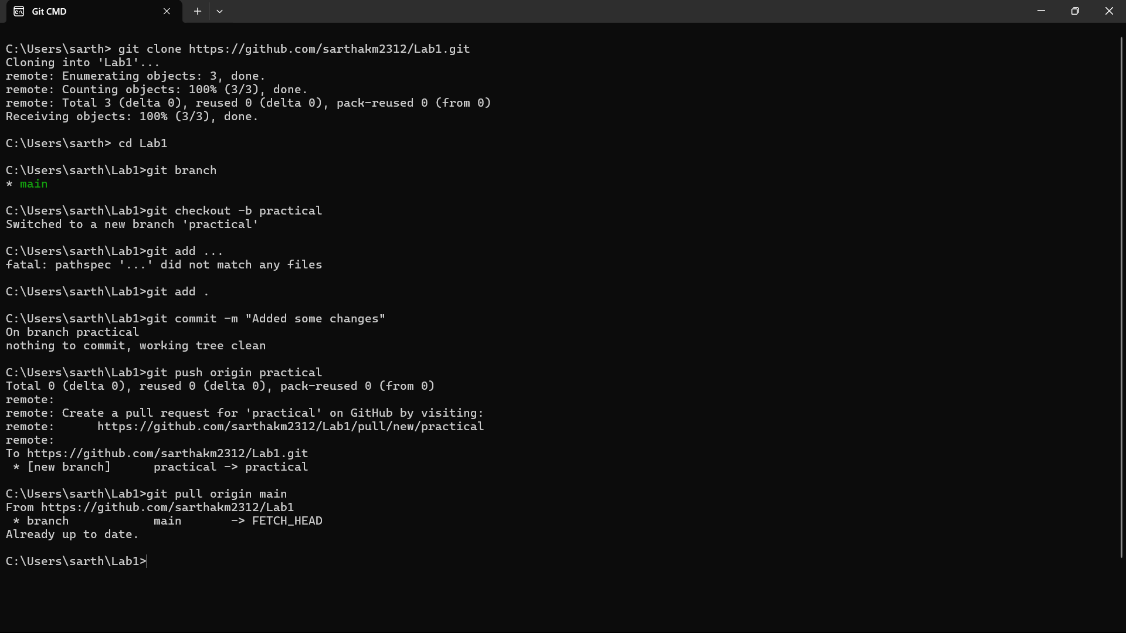

**Problem Statement:**

Create a public git repository for your team and submit the repo URL as a solution to this assignment, Learn Git concept of Local and Remote Repository, Push, Pull, Merge and Branch.